Middlebush Giant
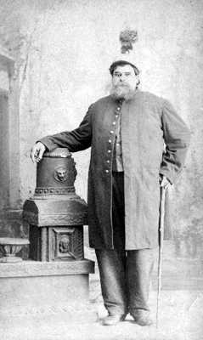
Billed as the world’s tallest man, Arthur James Caley (aka the Middlebush Giant), was given the stage name of Colonel Routh Goshen by P.T. Barnum. Stories about him abounded: Barnum either discovered him while traveling abroad, or first saw him on the streets of New York; he was either born on the Isle of Man, in 1827, or in Jerusalem in 1837 – Barnum made up so many stories about the big guy that he himself might not have remembered which one was true. At any rate, the circus billed the Middlebush Giant as standing 7’11” and weighing 620 pounds, but he most likely topped no more than 7’5″, around the same height as today’s tallest pro basketball players. “Colonel Routh Goshen” died in Middlebush, New Jersey, in 1889 and is buried there.

Mabel Stark
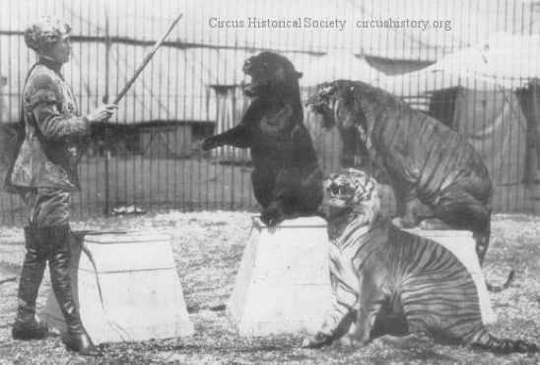
She may have been small in stature, standing just five feet tall, but the Marvelous Mabel Stark stood above the crowd as the greatest female tiger trainer in history. For a time, in the early1920’s, her act was the most popular of all six of Ringling’s world animal acts. In 1928, after she slipped in a muddy arena, two tigers knocked her to the ground and attacked her, clawing at her shoulders, arms and chest, and tearing muscles in her back, thigh and hip; her injuries required 378 stitches, but in just a few weeks, she was back in the steel cages, swathed in bandages and walking with a cane. In 1950, Mabel was attacked so brutally by one of her tigers that it took 175 stitches to save her right arm. The incidents didn’t stop fearless Mabel, though; she spent 57 years in the limelight, and died of a self-administered drug overdose after being fired from her last job, at a theme park called JungleLand.

Gargantua
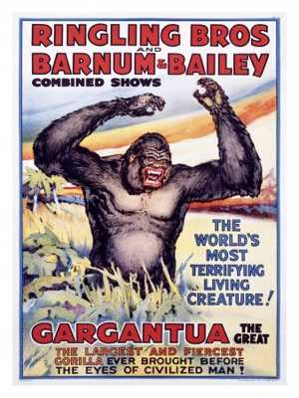
Billed as “the world’s most terrifying living creature,” the gorilla known as Gargantua the Great saved the Ringling brothers from bankruptcy when he joined the show, in 1938. The circus claimed that the scar-faced, snarling gorilla, captured in Africa as a baby, hated humans – thus piquing the interest of a lot of humans. In his early years, Gargantua, known as “Buddy,” was renamed by new owners after a giant in French literature, which, quite frankly, sounded a lot more frightening than “Buddy.” Gargantua apparently had a circus mate named Mrs. Gargantua, but her title was in name only because he never showed any interest in her.

Mario Zacchini
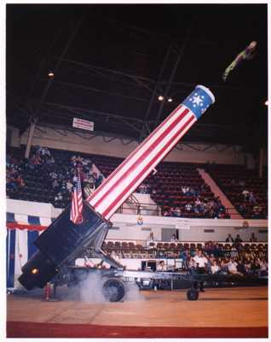
Wanted: “Man who wishes to be explosively propelled ninety miles an hour out of a cannon across a circus tent into a net.” Mario Zacchini apparently thought that sounded like a good job because, after committing to the feat, he and four of his brothers spent years being launched from a silver-painted cannon, three times a day with the Ringling Bros. and Barnum & Bailey Circus. The Zacchinis have acknowledged that their shattering cannon blasts were purely sound effects, achieved by igniting half a cup of black gunpowder, but Mario and his family never revealed the secret of the launching mechanism. Mario often said that “flying isn’t the hard part; landing in the net is.”

Harry Houdini
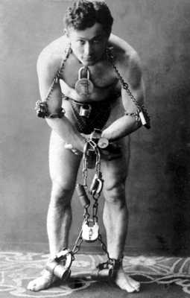
One of the world’s greatest magicians got his start with the Welsh Brothers Circus in Lancaster, Pennsylvania, in 1895. For 26 weeks, Harry Houdini and his wife, Beatrice, sang, danced and performed a trick called “metamorphosis,” in which they switched places in a locked trunk. Houdini continued to hone his voice and showmanship while becoming an expert at handcuff manipulation. The rest is history: his expertise in escapism launched him into international stardom far away from the circus world.

Flying Wallendas
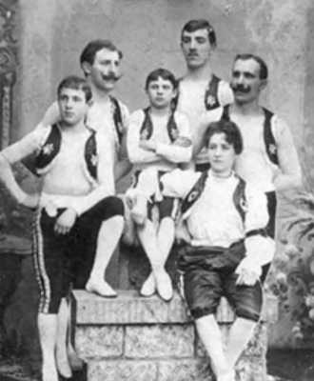
In 1922, Karl Wallenda formed a foursome called the Great Wallendas. They toured Europe, performing daredevil acts like forming a four-man pyramid and cycling across a tightrope high above the crowd. John Ringling was so impressed with a performance he saw in Cuba, that he hired them to perform for the Ringling Bros. and Barnum & Bailey Circus. They debuted at Madison Square Garden, in 1928, and performed without a net because it had been lost in transit. The act was a crowd-pleaser, but it wasn’t always fall-proof. At an Akron, Ohio performance, the group fell from the high-wire to the ground, but they were unhurt. A reporter witnessed the accident and said, “The Wallendas fell so gracefully that it seemed as if they were flying,” and that’s how the Great Wallendas became the Flying Wallendas. Forty-odd years later, on March 22, 1978 in San Juan, Puerto Rico, Wallenda fell to his death from the high wire at the age of 73.

General Tom Thumb
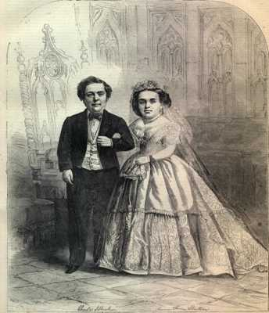
In 1842, Barnum hired four-year old dwarf Charles Stratton, who soon became world-famous as General Tom Thumb. Only 25 inches tall, Stratton started touring the United States with Barnum’s circus, impersonating characters like Cupid and Napoleon Bonaparte. He also sang, danced and participated in skits. In 1844, Barnum took him on a European tour, where he appeared twice before Queen Victoria and became an international celebrity. But it was his wedding (by which time he’d grown to his adult height of 2’11”) to 2’8″ Lavinia Warren, in 1863, that drew the greatest public attention. Barnum charged $75 per ticket and 2,000 people – including congressional representatives, millionaires, and generals – attended. During their honeymoon, the little couple were wined and dined by President and Mrs. Lincoln at the White House.

Emmet Kelly
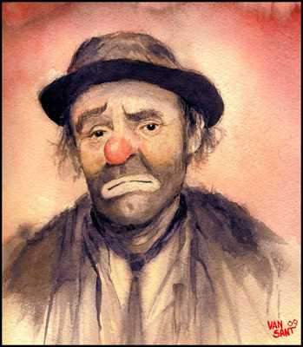
Emmett Kelly’s best known routine was trying to sweep a spotlight into a dustpan on the Ringling circus stage. From 1942 to 1956, he appeared as a classic tramp clown called “Weary Willie,” his version of a Depression-era hobo. Kelly’s style was different from his flashy peers: he wandered around the arena dressed in tattered clothing, using pantomime instead of words to connect with the crowd. He died, aged 80, of a heart attack in Sarasota, Florida, which was the longtime winter quarters of the Ringling Bros. and Barnum & Bailey Circus.

Isaac Van Amburgh—“The Great Lion Tamer”
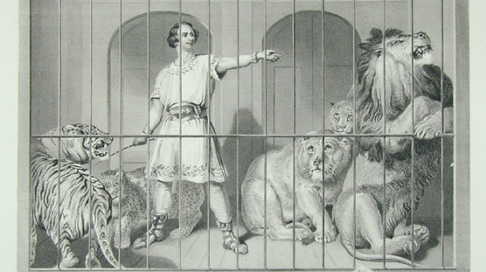
From his humble origins as an assistant at a menagerie called the Zoological Institute of New York, the flamboyant Isaac Van Amburgh grew into the most famous lion tamer of the 19th century. His act was renowned for its extreme daring. After entering the cage clad in ancient Roman garb, Van Amburgh would taunt his collection of lions, tigers and leopards and force them to stand on his shoulders and let him ride on their backs. He would also act out scenes from the Bible by introducing a lamb and a young child into the mix and having them sit alongside his big cats as though they were its own cubs. For his big finish, the great tamer would soak his arm or his head in blood and fearlessly thrust it between a lion’s gaping jaws. Most of Van Amburgh’s tricks were achieved through sheer brutality—he subdued his animals by beating them with whips and crowbars—but they won him widespread acclaim in the United States and Europe. His most famous admirer was the British Queen Victoria, who attended his London show seven times in 1839 and later commissioned a painting of him reclining with his cats.

Annie Oakley—“The Peerless Lady Wing-Shot”
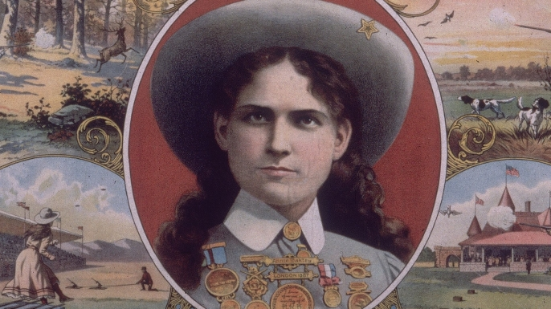Advertisement for Buffalo Bill’s Wild West Show, featuring Annie Oakley. (Credit: Fotosearch/Getty Images).
Phoebe Anne Moses first honed her rifle skills while hunting wild game during her childhood in Ohio. After marrying vaudeville performer Frank Butler in the 1870s, she took the name “Annie Oakley” and toured with circuses as a professional sharpshooter. By the 1880s, the young deadeye had joined the frontier extravaganza “Buffalo Bill’s Wild West” and become its highest paid performer. Her arsenal of tricks including hitting the edge of a playing card from 30 paces, snuffing out a candle with a bullet, blasting targets while riding a bike and even shooting a lit cigarette from her husband’s lips. Crowds were entranced by Oakley’s superhuman marksmanship and folksy personality, and she eventually spent some three decades touring the world with the Wild West and other shows. Before retiring in 1913, she performed for the likes of Queen Victoria, Kaiser Wilhelm II and Thomas Edison, who once filmed one of her shooting exhibitions with a newly invented kinetoscope camera.

Jules Leotard—“The Daring Young Man on the Flying Trapeze”
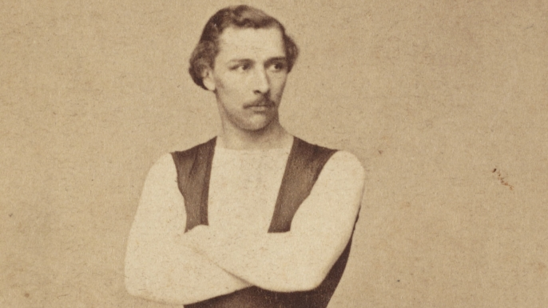Photo of the French acrobat Jules Léotard, 1865. (Credit: SSPL/Getty Images)
French-born acrobat Jules Leotard is remembered as the first man in history to attempt a flying trapeze act. The son of a gymnasium owner, he first practiced the high-flying stunt over his family’s swimming pool before unveiling it in 1859 at the Cirque Napoleon in Paris. He later took his act to London, where he captivated audiences by somersaulting between five different trapezes with only a pile of old mattresses to break his fall. Leotard’s death-defying deeds made him into something of a sensation during the 1860s, but his career was tragically cut short after he died of disease at the age of 28. By then, the intrepid aerialist had already been immortalized in the popular song “The Daring Young Man on the Flying Trapeze.” He also became the namesake for the “leotard,” the snug, one-piece garment that he had designed to show off his physique during performances.

Zazel—“The Human Projectile”
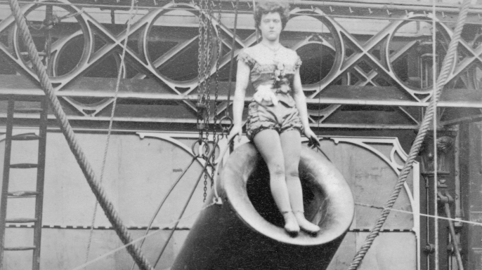Rosa Maria Richter, billed as ‘”Zazel,” at the start of her act at London’s Royal Aquarium, 1877. (Credit: Hulton Archive/Getty Images)
In 1877, the world’s first recorded human cannonball took flight when teenaged acrobat Rosa Richter—better known by her stage name “Zazel”—was shot into the air at the Royal Aquarium in London. The “cannon” that sent her airborne was invented by tightrope walker William Leonard Hunt and consisted of coiled springs attached to a foot platform. When the springs propelled Zazel out of the barrel and into a waiting safety net, a worker would set off a gunpowder charge to recreate the look and sound of a cannon shot. Word of Zazel’s death-defying stunt quickly spread, and it wasn’t long before crowds of up to 15,000 people were gathering to watch her soar over their heads. The young daredevil later toured with P.T. Barnum’s circus in the United States, but her luck finally ran out in 1891, when she overshot the net during a performance in New Mexico. While Zazel survived, a broken back forced her to retire from the circus for good.

Charles Blondin—“The Great Blondin”
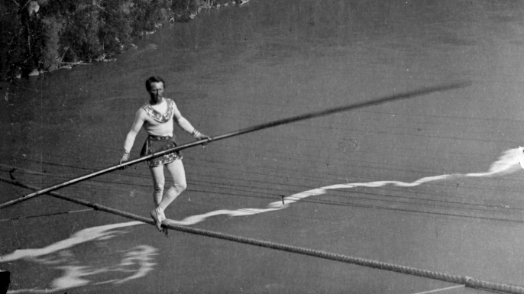Charles Blondin crossing Niagara Falls on a tightrope. (Credit: William England/Getty Images)
French daredevil Charles Blondin made his first circus appearance as a young boy, when he performed somersaults and wire dancing under the name “The Little Wonder.” He was a skilled acrobat and athlete—he once leapt over two lines of soldiers holding fixed bayonets—but he was most famous for his heart-pounding exploits as a tightrope walker. In June 1859, a 35-year-old Blondin made history when he strung a 1,300-foot hemp rope between the American and Canadian sides of Niagara Falls and strolled across the chasm, pausing along the way to enjoy a few swigs from a bottle of wine. He later repeated the stunt on multiple occasions, each time with a new and seemingly suicidal twist. He conquered the falls on stilts, with a sack over his head, wearing chains, pushing a wheelbarrow and even while carrying his terrified manager on his back. Most famous of all was the time he crossed with a cooking stove and stopped halfway to prepare an omelet—all while balancing on a 2-inch-wide rope suspended some 160 feet above the water. He became world famous, so much so that several imposters and imitators used his name to get publicity for their own tightrope stunts.

May Wirth—“The World’s Greatest Bareback Rider”
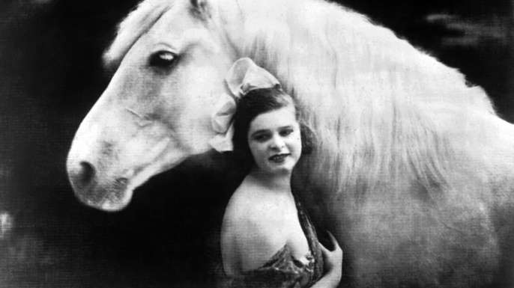May Wirth and her horse, circa 1920. (Credit: Gamma-Keystone via Getty Images)
Trick riding and equestrian stunts were a fixture under the big top from its early days in the 18th century, but few riders ever became as famous as Australia native May Wirth. Born into a circus family in 1894, she got her start as a child wirewalker and contortionist before hopping on horseback at age 10. She later joined Barnum and Bailey’s circus in America, where she dazzled audiences with an act that combined acrobatics with expert bareback riding. Wirth could perform a forward flip on horseback from a kneeling position—the first woman to do so—and perfected a trick where she did somersaults from one moving horse to another. The dainty, 4-foot-11-inch rider also showed off her physical strength by leaping from the ground onto the back of a galloping stallion, sometimes while blindfolded and wearing heavy baskets on her feet. Wirth’s good looks and daring stunts won her legions of admirers and frequent mentions in the gossip pages of newspapers. By the time she finally retired in 1937, she had spent 25 years as one of the circus’s top female performers.

Lillian Leitzel—“The Queen of Aerial Gymnasts”
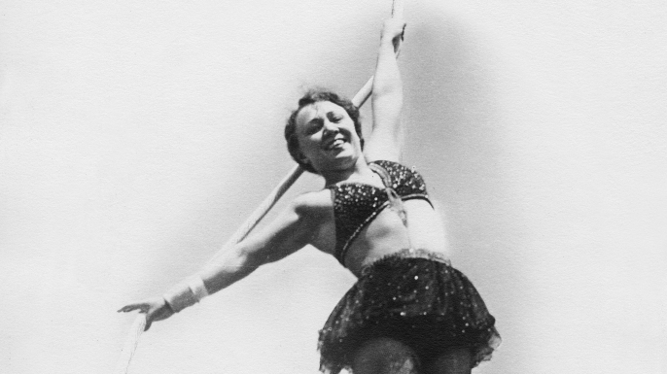Lillian Leitzel (Credit: ullstein bild/ullstein bild via Getty Images)
During the golden age of the circus in the early 20th century, no star shone brighter than that of German-born aerialist Lillian Leitzel. She captivated audiences with an act that consisted of acrobatic tricks and poses performed while hanging from Roman rings suspended 50 feet above the ground—always without a safety net below. For her grand finale, she would grasp the ring with one hand and flip head over heels so rapidly that her arm would dislocate and then snap back into place with each turn. The spellbinding routine made Leitzel into an international diva. She was voted “the most beautiful and attractive woman in all the world” by American soldiers during World War I, and she became the first Ringling Brothers and Barnum and Bailey star to receive a private train car while on tour. Leitzel continued her physically demanding act well into her 30s, but her career ended in tragedy in 1931, when a piece of metal on her rigging snapped during a performance in Copenhagen and sent her plummeting to the floor. She died from her injuries just two days later.

Chang and Eng Bunker, Siamese Twins
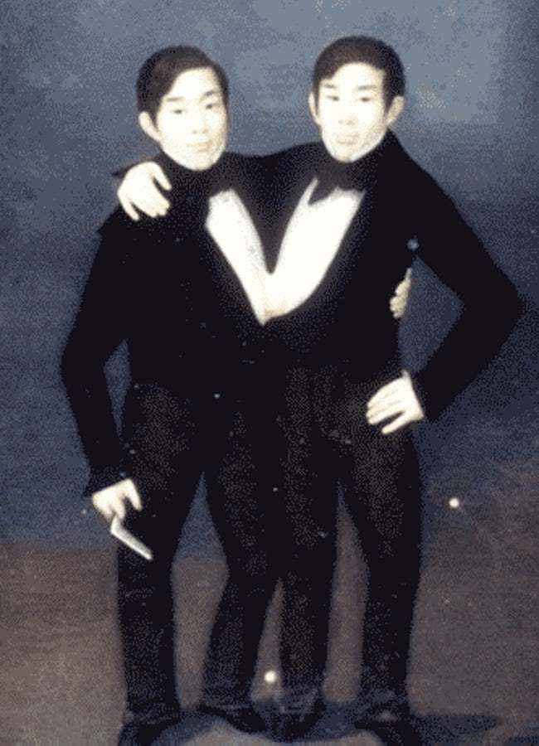Photo: Freebase/Public domain
These "Siamese Twins" are the basis for the colloquial term applied to conjoined twins today. Chang and Eng Bunker were from a family of multiples but were the only two siblings that were born conjoined. Born in 1811 in Thailand, they entered show business in 1829 when they were purchased by an American colonel. They took control of their own career during the early 1830s and retired in 1838. The worked with Barnum on occasion during the 1850s and 1860s to tour. After the Civil War, they once again worked with Barnum because they needed the money.
After they left show business, they moved to North Carolina and became US citizens, changing their name to Bunker. They married a set of sisters, Sarah and Adelaide Yates. Between the two of them they fathered 22 children. Chang and Eng died in 1874. An autopsy revealed they could not have been separated in a way that would have allowed for them both to survive.

Annie Jones, Bearded Woman
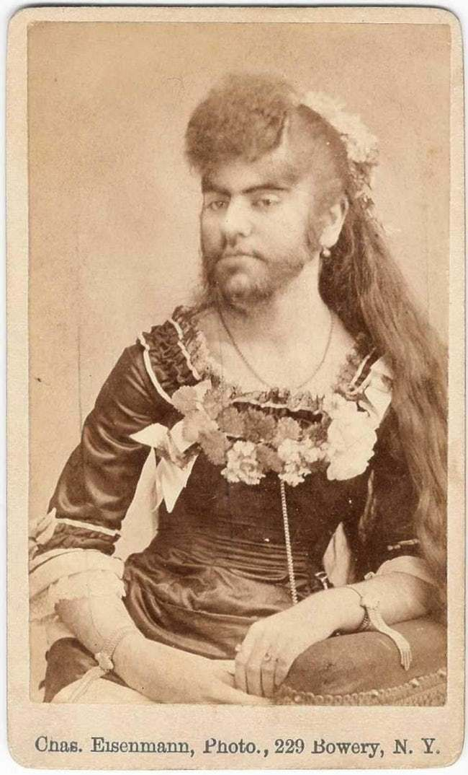Photo: Charles Eisenmann/WikiMedia Commons/CC BY-SA 3.0
Annie Jones was one of the first bearded women in the US. She was born in Virginia in 1865 and was said to have been hairier than her father at birth. She also had hypertrichosis and, after Barnum heard about her, was brought to New York as an infant.
At one point Annie was kidnapped by a phrenologist who wanted to display her at a fair. Her mother was able to get her back and she returned to Barnum's show where he advertised her "fine silken beard, whiskers, and moustache." She was both the "Bearded Girl" and the "Bearded Lady" during her long career. She married twice and returned to Barnum's show after her second husband's death. She died in 1902 after spending years championing for "freaks" and trying to end the use of the term.

Madam Yucca And Sandwina, Strongwomen
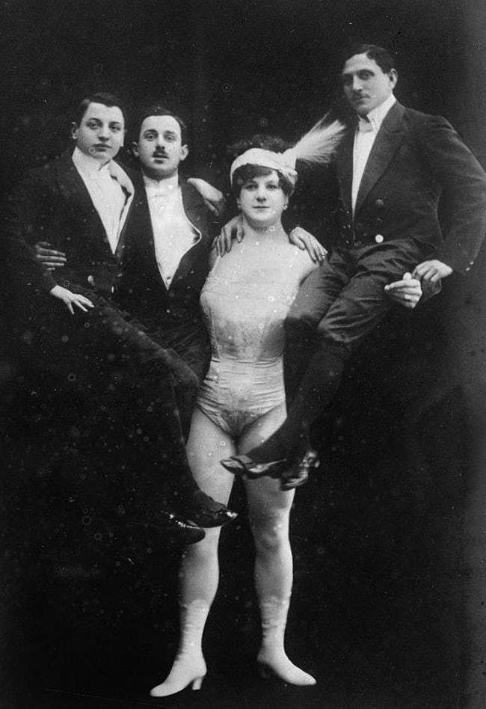Photo: https://upload.wikimedia.org/wikipedia/commons/2/22/Katie_Sandwina_%28the_Lady_Hercules%29.jpg/WikiMedia Commons/CC BY-SA 3.0
As "Female Hercules" in the show during the 1890s, Madam Yucca would juggle dumbbells and lift a 1,600 lb horse off of the ground during her act.
Kate Sandwina, whose real name was Kate Bambach, was born in Vienna in 1884 to strength performers and soon took after her parents. After winning a lifting contest with famous bodybuilder Eugen Sandow, she adopted the name "Sandwina" to signify her victory. She challenged men in the audience at shows to contests of strength. In her act for Barnum and Bailey, which she joined in 1911, she would lift her husband over her head with one arm while lifting other objects with the other. She was promoted as "the Strongest Woman On Earth" and the "Female Hercules."

